Assignment 6
Q 1
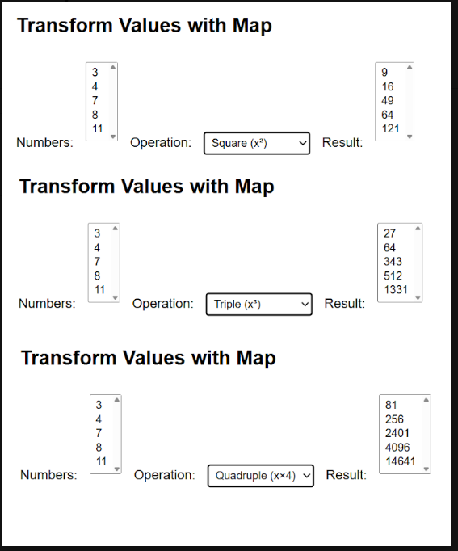
<!DOCTYPE html>
<html lang="en">

<head>
<meta charset="UTF-8">
<meta name="viewport" content="width=device-width, initial-scale=1.0">
<title>Document</title>
<link rel="stylesheet" href="bootstrap-5.3.8/dist/css/bootstrap.min.css">
</head>

<body style="background-color: rgb(230, 220, 172);">

<div class="container mt-5">
<div class="card shadow">
<div class="card-body">
<div class="row">

<div class="col-md-4 p-5">
<select multiple name="numbers" id="numbers"></select>
</div>

<div class="col-md-4 p-5">
<select name="options" id="options">
<option value="3">For cube n^3 of numbers</option>
<option value="2">For Squer n^2 of numbers</option>
<option value="4">For n^4 of numbers</option>
</select>
</div>

<div class="col-md-4 p-5">
<select multiple name="resultNum" id="resultNum"></select>
</div>

</div>
</div>
</div>
</div>
<script>

const numbers = [];
const selectNumbers = document.getElementById("numbers");
for (let i = 1; i < 10; i++) {
const option = document.createElement("option");
numbers.push(i)
option.value = i;
option.textContent = i;
selectNumbers.appendChild(option);
}

const selectOption = document.getElementById("options");
const selectResult = document.getElementById("resultNum");

function updateResults() {
selectResult.innerHTML = "";
let power = parseInt(selectOption.value);

const results = numbers.map(n => n ** power);

results.forEach((res, index) => {
const optionRes = document.createElement("option");
optionRes.value = res;
optionRes.textContent = res;
selectResult.appendChild(optionRes);
});
}

updateResults();

selectOption.addEventListener("change", updateResults);

</script>

</body>

</html>

